HYDRAM’S SOLUTION

Corner former

CORNER FORMER IMAGE

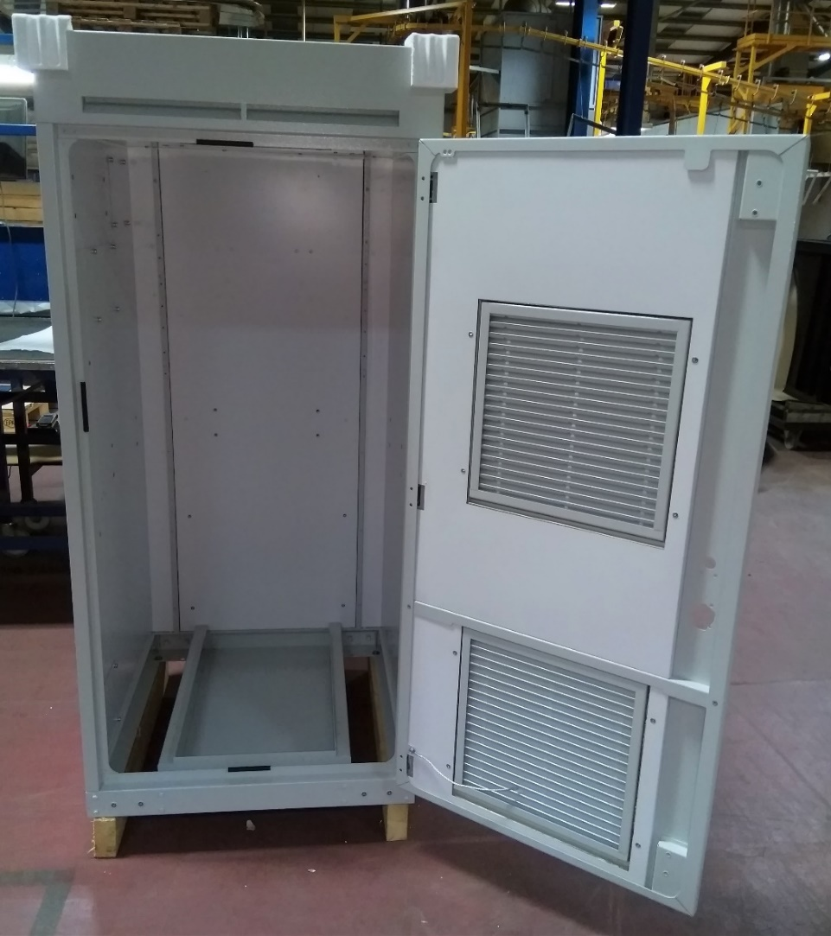

Hydram's fabricated metal products range from relatively simple boxes to integrated units containing up to 200 subparts. Customers for these types product vary from the power generation industry to lighting, air conditioning, communications and vending.

CABINETS & ENCLOSURES

